**BACKEND: MERN STACK BOOTCAMP**

**Assignment No: 01**

**Name: Romaisa Amjad**

**Date: 6/3/2025**

**Question:**

Create a basic web server using core Node JS that can listen to requests and response to it. The server should have the following responses on different routes

1. /: Return a welcoming message.
2. GET:/products: Create a product array and send back all those into unordered list.
3. POST:/products: Send a message saying **Creating a product functionality is not implemented yet.**
4. /blog: Return a blog page having heading and paragraph.

Return **Route Not Found** with status code of **404** on all other routes.

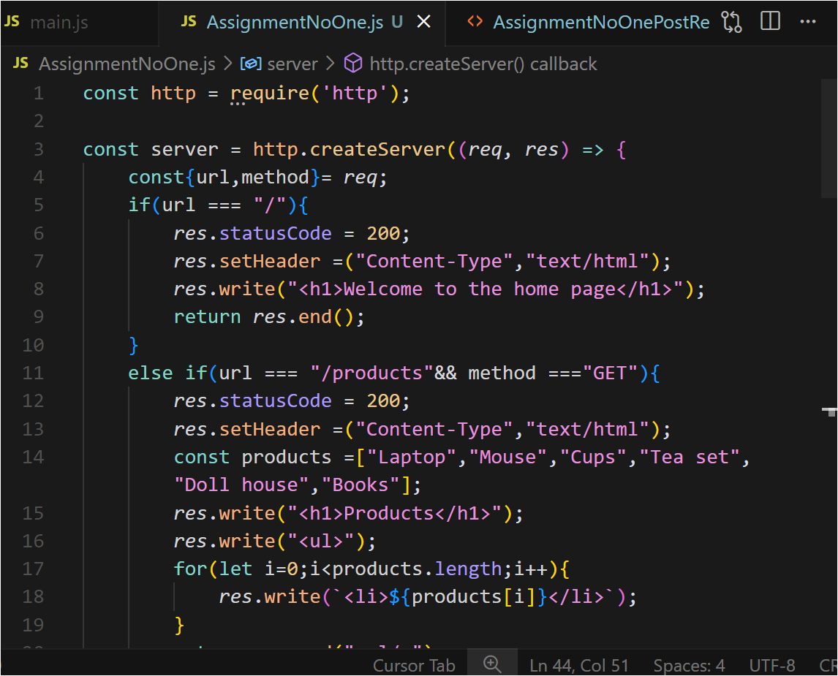**Code Implementation:**

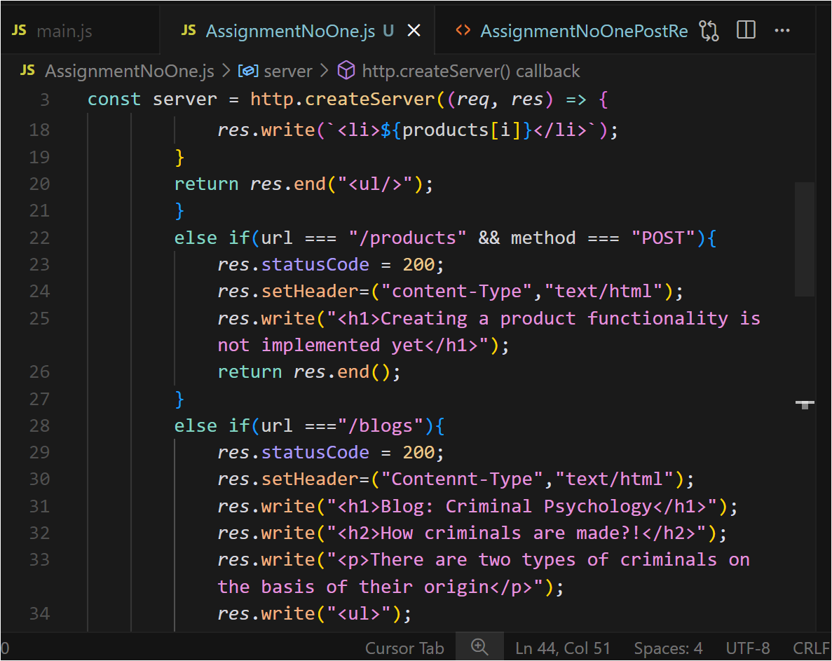

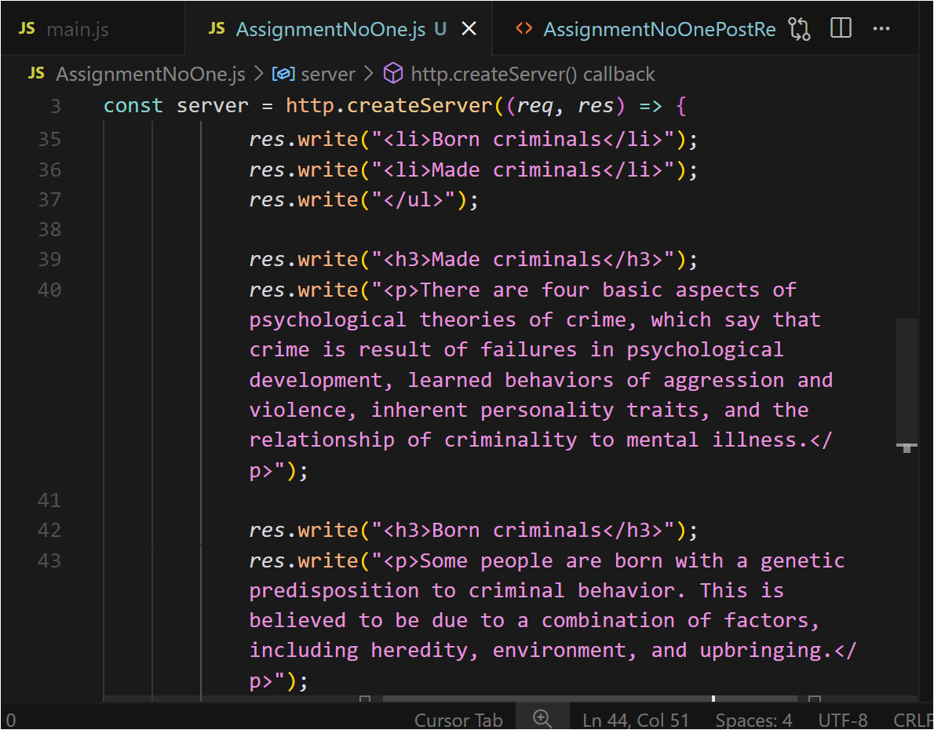

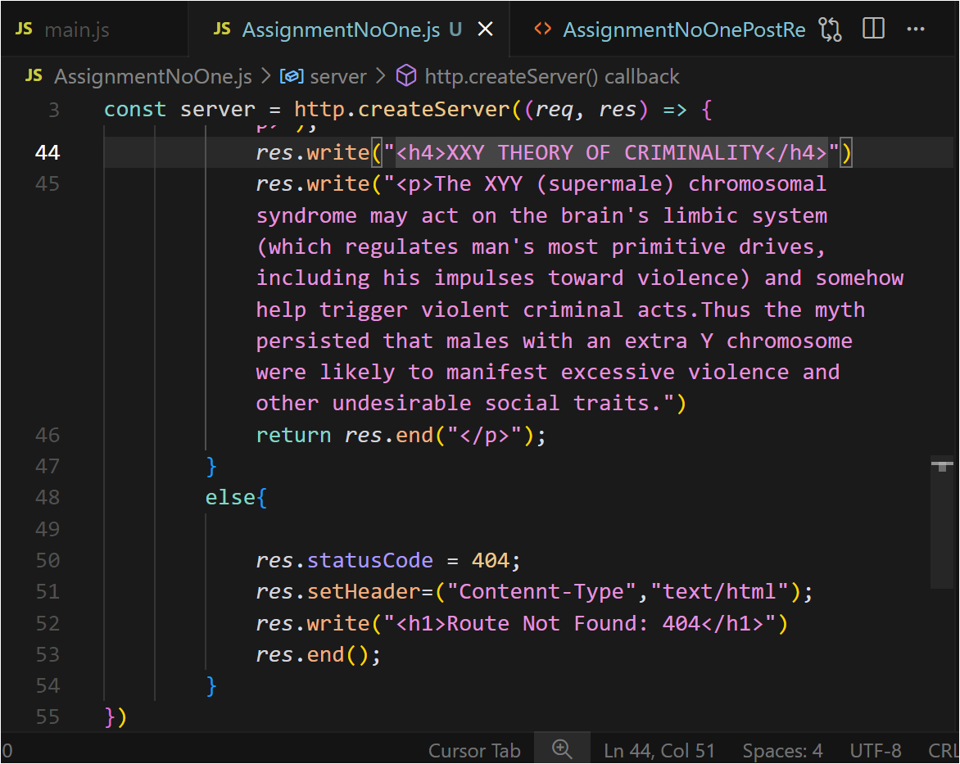

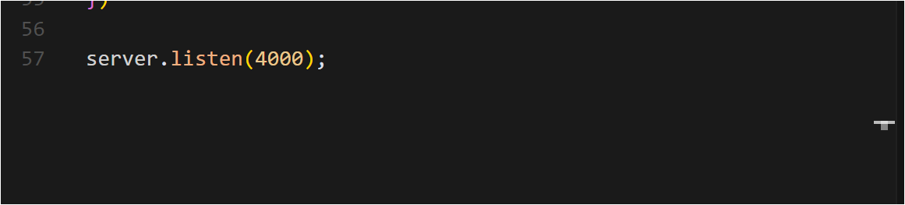

<!DOCTYPE html>

<html>

  <body>

    <h2>Create Product</h2>

    <form action="http://localhost:4000/products" method="POST">

      <button type="submit">Send POST Request</button>

    </form>

  </body>

</html>

**Output:**

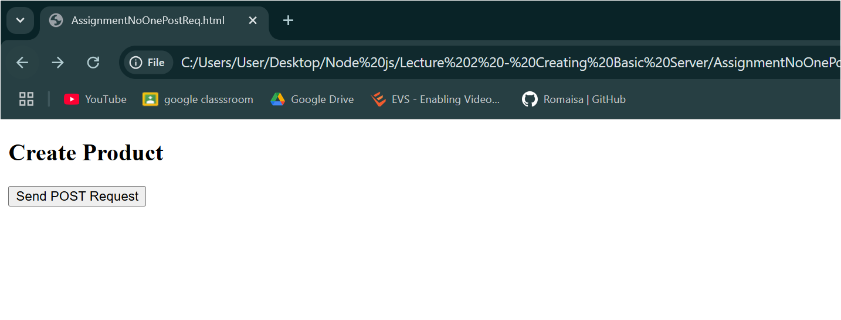

*On clicking the button*

